1.What is an Exception in Java?
Ans. The term “exception” means “exception condition” and is an occurrence that alters the normal program flow(hardware failure, resource exhaustion).

2.What are the Exception Handling Keywords in Java?
Ans. try and catch (try, catch and finally block)

3.Explain Java Exception Hierarchy?
Ans.
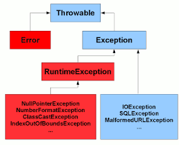

4.What are the important methods of Java Exception Class?
Ans. public String getMessage(), printStackTrace()

5.What is the difference between Checked and Unchecked Exceptions in Java?
Ans.
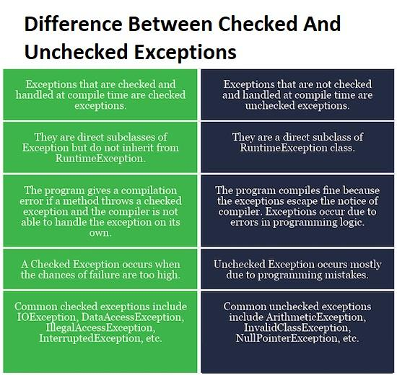

6.What is the difference between the throw and throws keyword in Java?
Ans. throw is a keyword which is used to throw an exception explicitly in the program inside a function or inside a block of code. throws is a keyword used in the method signature used to declare an exception which might get thrown by the function while executing the code.

7.How to write custom exceptions in Java?
Ans. class InvaliedAgeException extends Exception{
public static final long serialVersionUID = 1l;
public InvaliedAgeException(String s) {
super(s);
}

@Override
public String getMessage() {
return "MY MEssage";
}
}
8.What is OutOfMemoryError in Java?
Ans. OutOfMemoryError exception. Usually, this error is thrown when there is insufficient space to allocate an object in the Java heap. In this case, The garbage collector cannot make space available to accommodate a new object, and the heap cannot be expanded further.

Containment means composition or has-a relationship in java.
So if a class has variables which is of other class types then it is has relationship.
Containment is the simple approach, in which a class B, that needs access to the members of class A, contains an instance/object of class A, rather then inheriting the class A.
Example:
class Job{

private int id;
private String role;
private long salary;

public Job() {
id=0;
role="";
salary=0;
}

public Job(int id, String role, long salary) {

this.id = id;
this.role = role;
this.salary = salary;
}

public int getId() {
return id;
}

public void setId(int id) {
this.id = id;
}

public String getRole() {
return role;
}

public void setRole(String role) {
this.role = role;
}

public long getSalary() {
return salary;
}

public void setSalary(long salary) {
this.salary = salary;
}

@Override
public String toString() {
return "Job [id=" + id + ", role=" + role + ", salary=" + salary + "]";
}

}

class Person{
private String name;
private Job job; ///Containment object

public Person() {
name="";
job=new Job();
}

public Person(String name, Job job) {
super();
this.name = name;
this.job = job;
}

@Override
public String toString() {
return "Person [name=" + name + ", job=" + job + "]";
}
}

public class ContainmentExample {
public static void main(String[] args) {
Person p=new Person("Eshan",new Job(101,"HR",34455));

System.out.println(p);

}
}

Java Inner Classes
In Java, it is also possible to nest classes (a class within a class). The purpose of nested classes is to group classes that belong together, which makes your code more readable and maintainable.
To access the inner class, create an object of the outer class, and then create an object of the inner class:

Example
class OuterClass {
int x = 10;

class InnerClass {
int y = 5;
}
}

public class Main {
public static void main(String[] args) {
OuterClass myOuter = new OuterClass();
OuterClass.InnerClass myInner = myOuter.new InnerClass();
System.out.println(myInner.y + myOuter.x);
}
}

// Outputs 15 (5 + 10)

Private Inner Class
Unlike a "regular" class, an inner class can be private or protected. If you don't want outside objects to access the inner class, declare the class as private:

Example
class OuterClass {
int x = 10;

private class InnerClass {
int y = 5;
}
}

public class Main {
public static void main(String[] args) {
OuterClass myOuter = new OuterClass();
OuterClass.InnerClass myInner = myOuter.new InnerClass();
System.out.println(myInner.y + myOuter.x);
}
}

If you try to access a private inner class from an outside class (MyMainClass), an error occurs:
Main.java:13: error: OuterClass.InnerClass has private access in OuterClass
OuterClass.InnerClass myInner = myOuter.new InnerClass();
^

Static Inner Class
An inner class can also be static, which means that you can access it without creating an object of the outer class:

Example
class OuterClass {
int x = 10;

static class InnerClass {
int y = 5;
}
}

public class Main {
public static void main(String[] args) {
OuterClass.InnerClass myInner = new OuterClass.InnerClass();
System.out.println(myInner.y);
}
}

// Outputs 5

Note: just like static attributes and methods, a static inner class does not have access to members of the outer class.

Access Outer Class From Inner Class
One advantage of inner classes, is that they can access attributes and methods of the outer class:

Example
class OuterClass {
int x = 10;

class InnerClass {
public int myInnerMethod() {
return x;
}
}
}

public class Main {
public static void main(String[] args) {
OuterClass myOuter = new OuterClass();
OuterClass.InnerClass myInner = myOuter.new InnerClass();
System.out.println(myInner.myInnerMethod());
}
}

// Outputs 10
A static method can be accessed without creating an object of the class.
The static keyword is a non-access modifier used for methods and attributes. Static methods/attributes can be accessed without creating an object of a class.

Static keyword can be applied on:
class
block
method
variable

public class InnerClassDemoThree {

static int a=10;
static int b;

static {
System.out.println("static block is called");
b=a*4;
}

public static void main(String[] args) {
System.out.println("Main block");
System.out.println("A"+a);
System.out.println("B"+b);

}

}

class Student{
String name;
int rollNo;
static String cllgName;

static int counter=0;

public Student(String name) {
this.name=name;
this.rollNo=setRollNo();
}

static int setRollNo() {
counter++;
return counter;
}

static void setCllgName(String name) {
cllgName=name;
}

void showStudentInfo() {
System.out.println("NAme"+this.name);
System.out.println("Roll no"+this.rollNo);
System.out.println("col name"+cllgName);
}

}

public class StaticExample {

public static void main(String[] args) {
Student.setCllgName("ABC");

Student s1=new Student("EShan");
Student s2=new Student("Tanish");

s1.showStudentInfo();
s2.showStudentInfo();
}
}

Wrapper classes: are final

They furnish methods that provide basic capabilities such as class conversions, value testing etc
Constructors of wrapped classes allow objects to be created & converted from primitive values & strings
E.g. int intVal = 10;
int intObj = new Integer(intVal);

Need
To provide a home for methods & variables related to the type
Create objects to hold values for generically written classes that know how to handle only object references

Java provides 8 primitive data types. But sometimes there's a need to convert a primitive type to an object
All java primitive types have class counterparts
These are called object wrappers or wrapper classes

public class WrapperClassExample {

public static void xyz(Integer a) {
a=a*100;
}

public static void main(String[] args) {

@SuppressWarnings("removal")
Integer a=new Integer(100);

System.out.println("value of x is "+a);
xyz(a);
System.out.println("value of x is "+a);

}
}

